- Create an S3 bucket and upload some objects to S3.
Option 1: AWS Management Console (GUI way)
Login to your AWS account → Go to S3 Service.
- Click “Create bucket”.
  - Enter a unique bucket name (e.g., funbos12345678).
  - Choose AWS Region (e.g., united States noerth Virginia).
  - Keep defaults for settings unless you want versioning/encryption.
  - Click Create bucket.
- Open the bucket → Click Upload.
- Choose Add files (pick any file from your system, like test.txt or image.png).
- Click Upload.
- Now your objects will be stored in S3 and visible in the bucket.
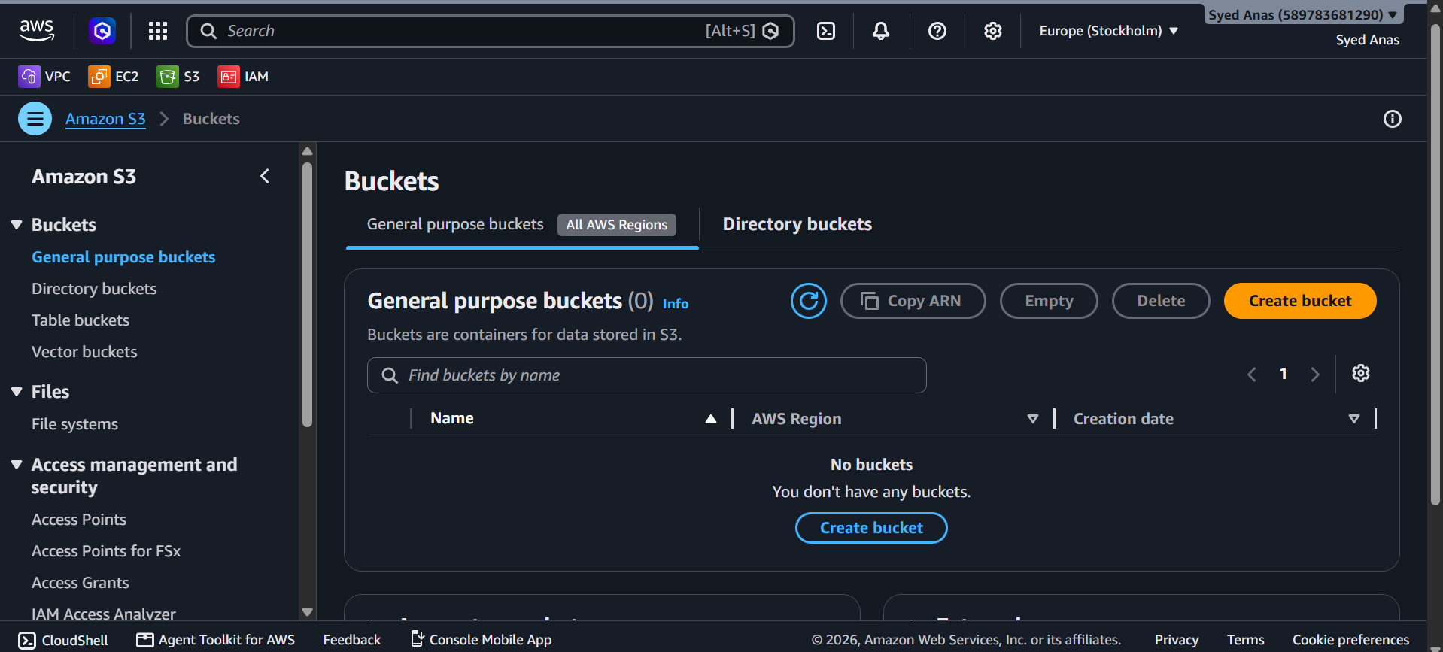
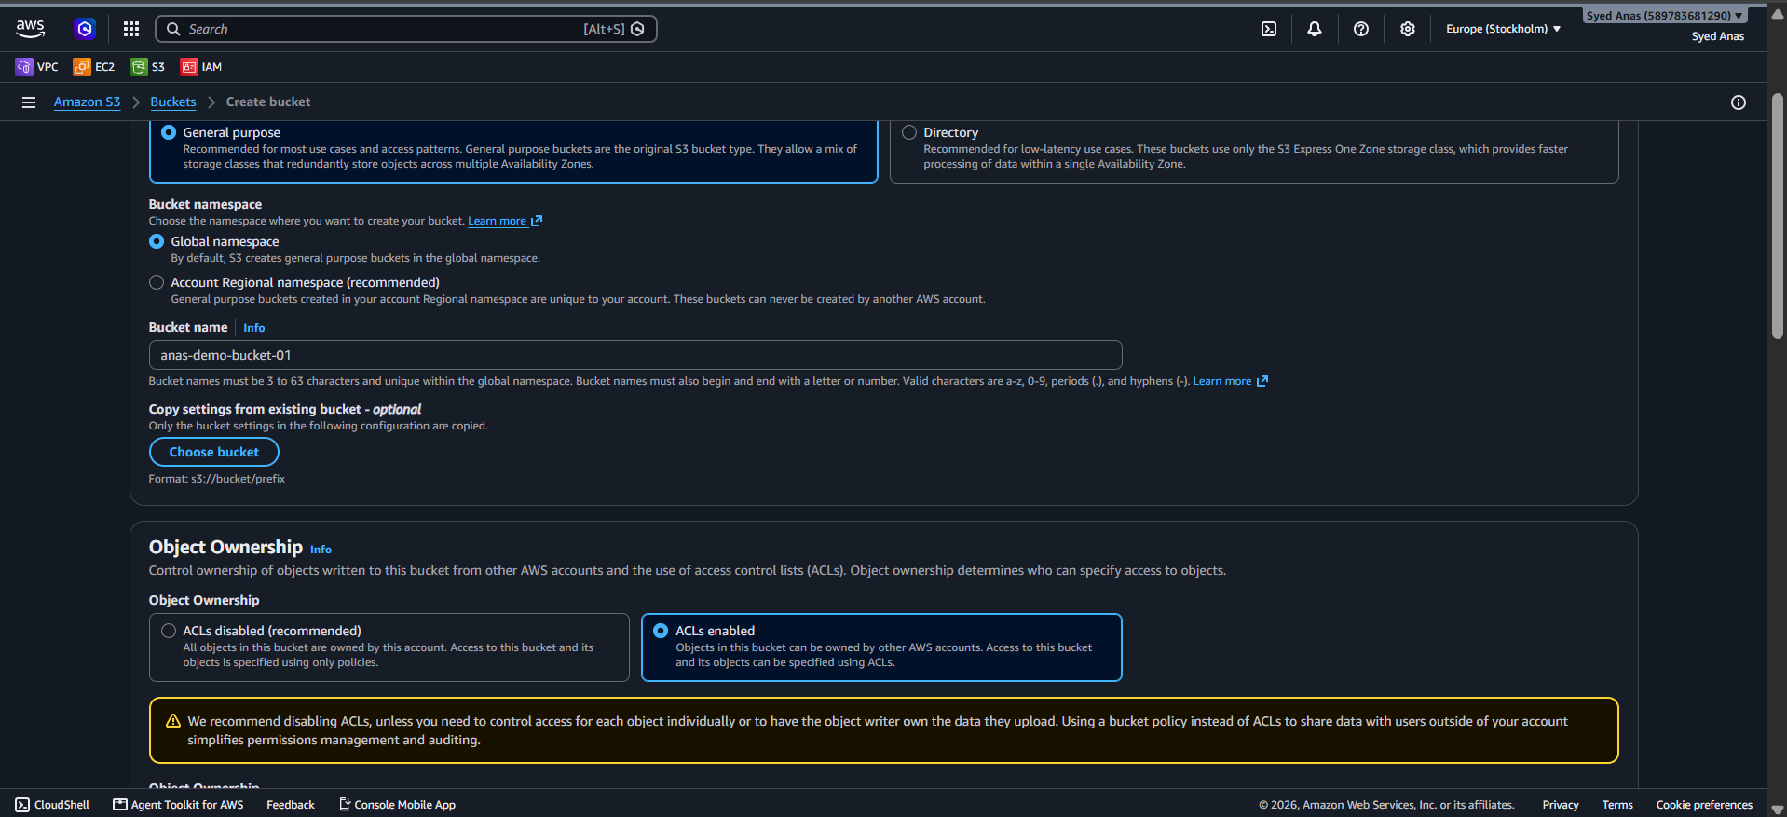

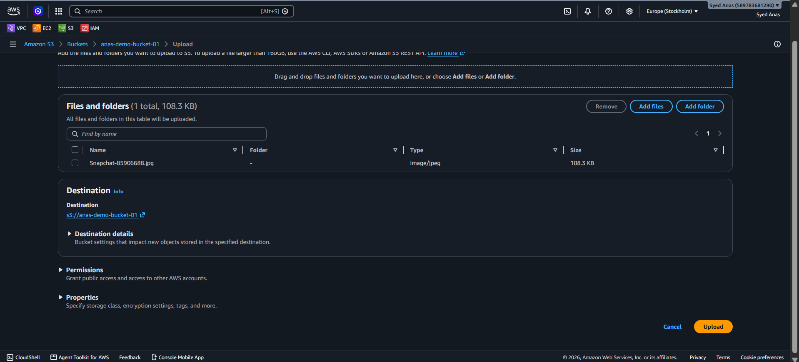
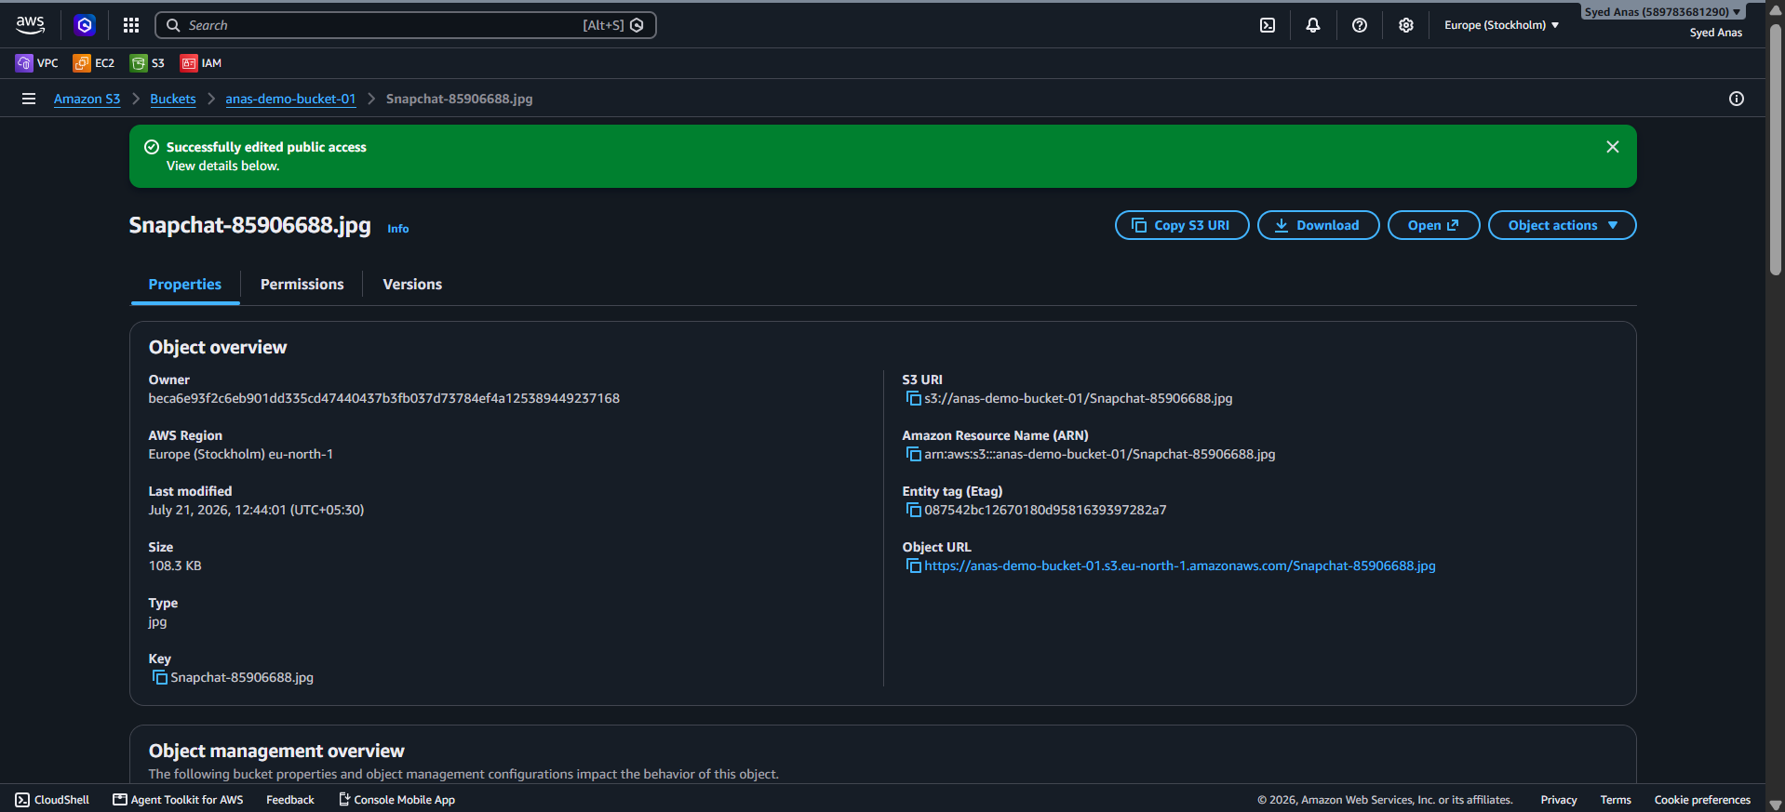

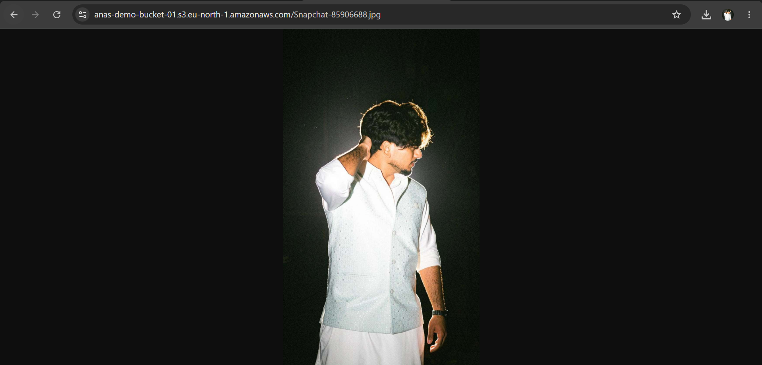

Option 2: AWS CLI (Command Line way)
Step 1: Configure AWS CLI (if not done already)
aws configure
Enter your Access Key, Secret Key, Region, and Output format (json).
Step 2: Create an S3 bucket
Bucket names must be globally unique.
aws s3 mb s3://my-first-s3-bucket-gayas-2025 --region ap-south-1
Step 3: Upload a file to S3
aws s3 cp myfile.txt s3://my-first-s3-bucket-gayas-2025/
For multiple files:
aws s3 cp /local/folder s3://my-first-s3-bucket-gayas-2025/ --recursive
Step 4: Verify objects in S3
aws s3 ls s3://my-first-s3-bucket-gayas-2025/
You should see your uploaded files.

- Deploy a static website in the S3 bucket.

AWS Console Method
1. Create an S3 Bucket

  - Go to S3 in the AWS Console.
  - Click Create bucket.
  - Name it (e.g., my-static-site-md) and choose a region.
  - Uncheck Block all public access (important for website hosting).
  - Acknowledge the warning and create the bucket.

2. Upload Website Files
  - Open the bucket.
  - Click Upload and add your HTML, CSS, JS files (e.g., index.html, style.css).
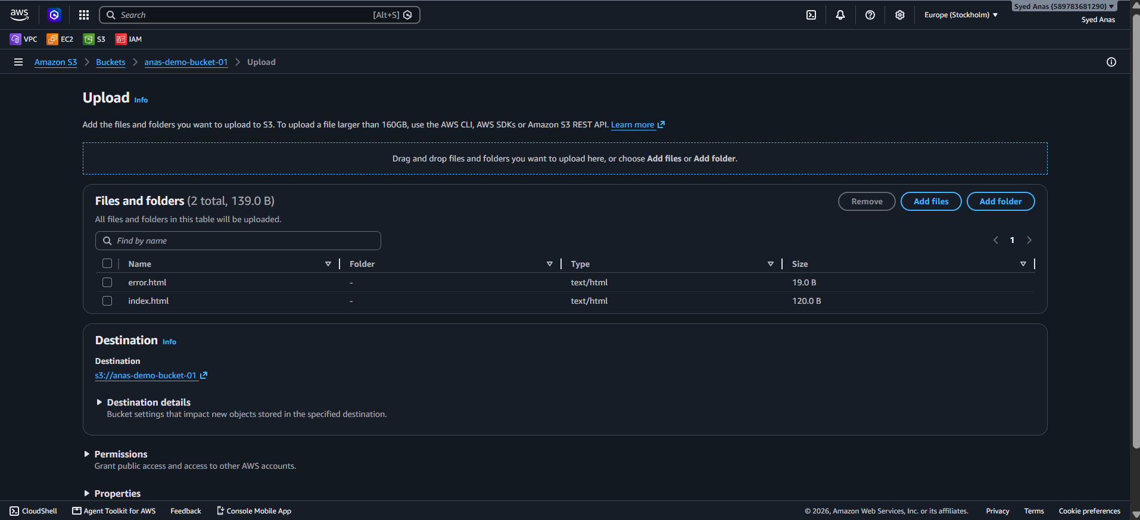
3. Enable Static Website Hosting
  - Go to Properties tab of the bucket.
  - Scroll to Static website hosting.
  - Click Edit, then:
    - Enable hosting.
    - Set index document to index.html.
    - (Optional) Set error document to error.html.
  - Save changes.
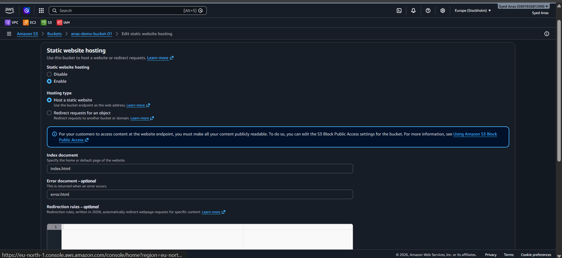
4. Set Bucket Policy for Public Access
Go to Permissions > Bucket Policy and paste this (replace your-bucket-name):
{
"Version": "2012-10-17",
"Statement": [
{
"Sid": "PublicReadGetObject",
"Effect": "Allow",
"Principal": "*",
"Action": "s3:GetObject",
"Resource": "arn:aws:s3:::your-bucket-name/*"
}
]
}

Click save.
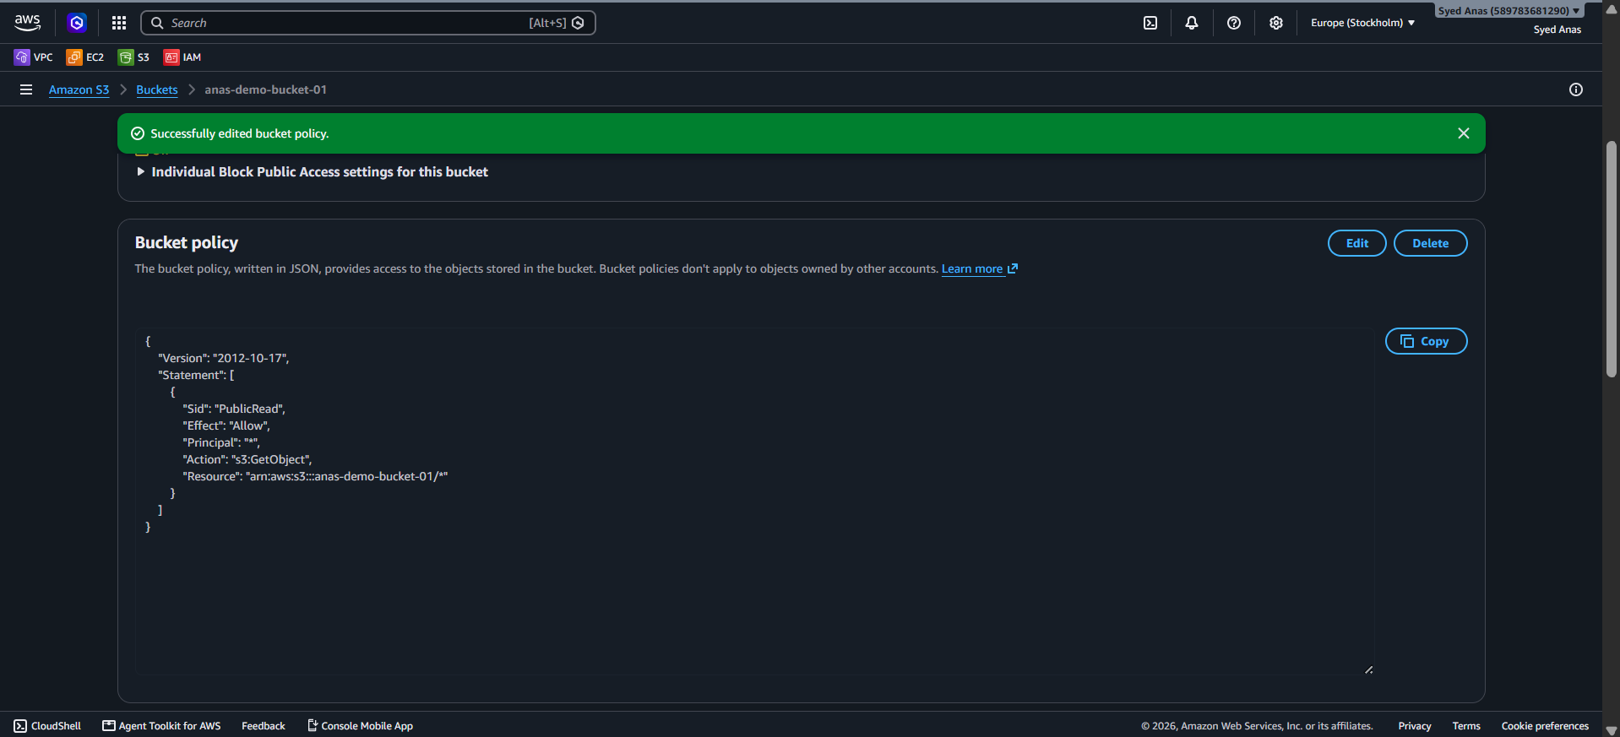
5. Access Your Site
- Go back to Properties > Static website hosting.
- Copy the bucket website endpoint — that’s your live site URL!
Paste it in your browser to view your site!
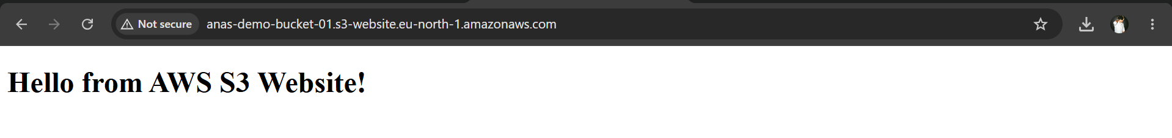

- Enable cross-region replication on S3 buckets.
🌍 Step-by-Step: Enable Cross-Region Replication (CRR) in S3
✅ Prerequisites
- Two buckets: One source bucket and one destination bucket in different AWS regions.
- Versioning enabled on both buckets.
- Proper IAM permissions for replication.
1. Create Destination Bucket
- Go to S3 Console.
- Click Create bucket.
Choose a different region than the source bucket.
- Enable Bucket Versioning.
- Click Create bucket.
2. Enable Versioning on Source Bucket
- Open the source bucket.
- Go to Properties → Bucket Versioning.
- Click Enable and save.
3. Set Up IAM Role for Replication
- AWS can create the role automatically during setup.
- Or manually create a role with s3:ReplicateObject, s3:ReplicateDelete, and s3:ReplicateTags permissions.
4. Configure Replication Rule
- Go to the source bucket → Management tab.
- Click Replication → Create replication rule.
- Set a rule name.
- Choose Entire bucket or a specific prefix/tag.
- Select the destination bucket.
- Choose to replicate:
Delete markers
  - Replicated metadata
  - Replicated tags
- Choose or create an IAM role.
- Click Save.
5. Verify Replication
- Upload a file to the source bucket.
- Check the destination bucket in the other region.
- It may take a few minutes for replication to occur.

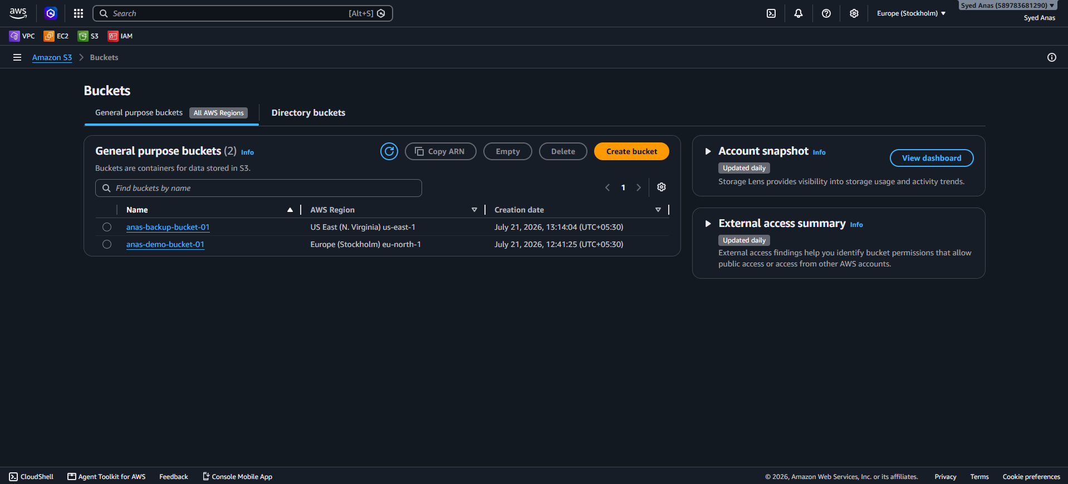
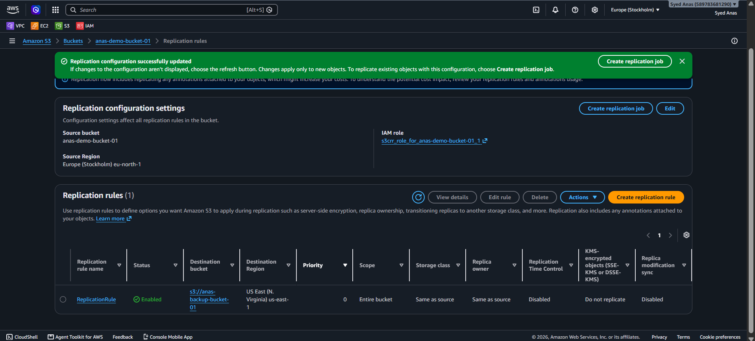
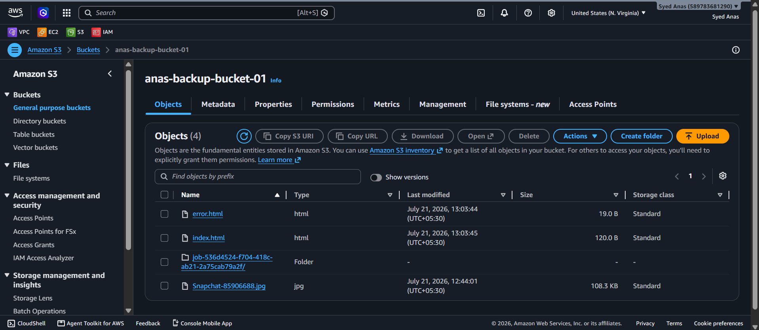

- Configure a bucket policy so only the Admin user can see the objects of the S3 bucket.
Step 1: Prerequisites
Before setting the policy, make sure:
- You already have an S3 bucket created (example: my-private-bucket).
- You have an IAM user named “Admin” (or any specific IAM username).
- The “Admin” user has programmatic access or console access.

Step 2: Find the Admin User’s ARN
Go to:
IAM Console → Users → Admin → Summary tab
Copy the ARN (Amazon Resource Name).
Example:
arn:aws:iam::123456789012:user/Admin

Step 3: Create the Bucket Policy
- Go to your S3 bucket → Permissions → Bucket policy → Edit.
- Paste the following JSON policy (replace bucket name and ARN):
{
"Version": "2012-10-17",
"Statement": [
{
"Sid": "AllowOnlyAdminUserAccess",
"Effect": "Allow",
"Principal": {
"AWS": "arn:aws:iam::123456789012:user/Admin"
},
"Action": [
"s3:GetObject",
"s3:ListBucket"
],
"Resource": [
"arn:aws:s3:::my-private-bucket",
"arn:aws:s3:::my-private-bucket/*"
]
},
{
"Sid": "DenyAllOtherAccess",
"Effect": "Deny",
"NotPrincipal": {
"AWS": "arn:aws:iam::123456789012:user/Admin"
},
"Action": "s3:*",
"Resource": [
"arn:aws:s3:::my-private-bucket",
"arn:aws:s3:::my-private-bucket/*"
]
}
]
}
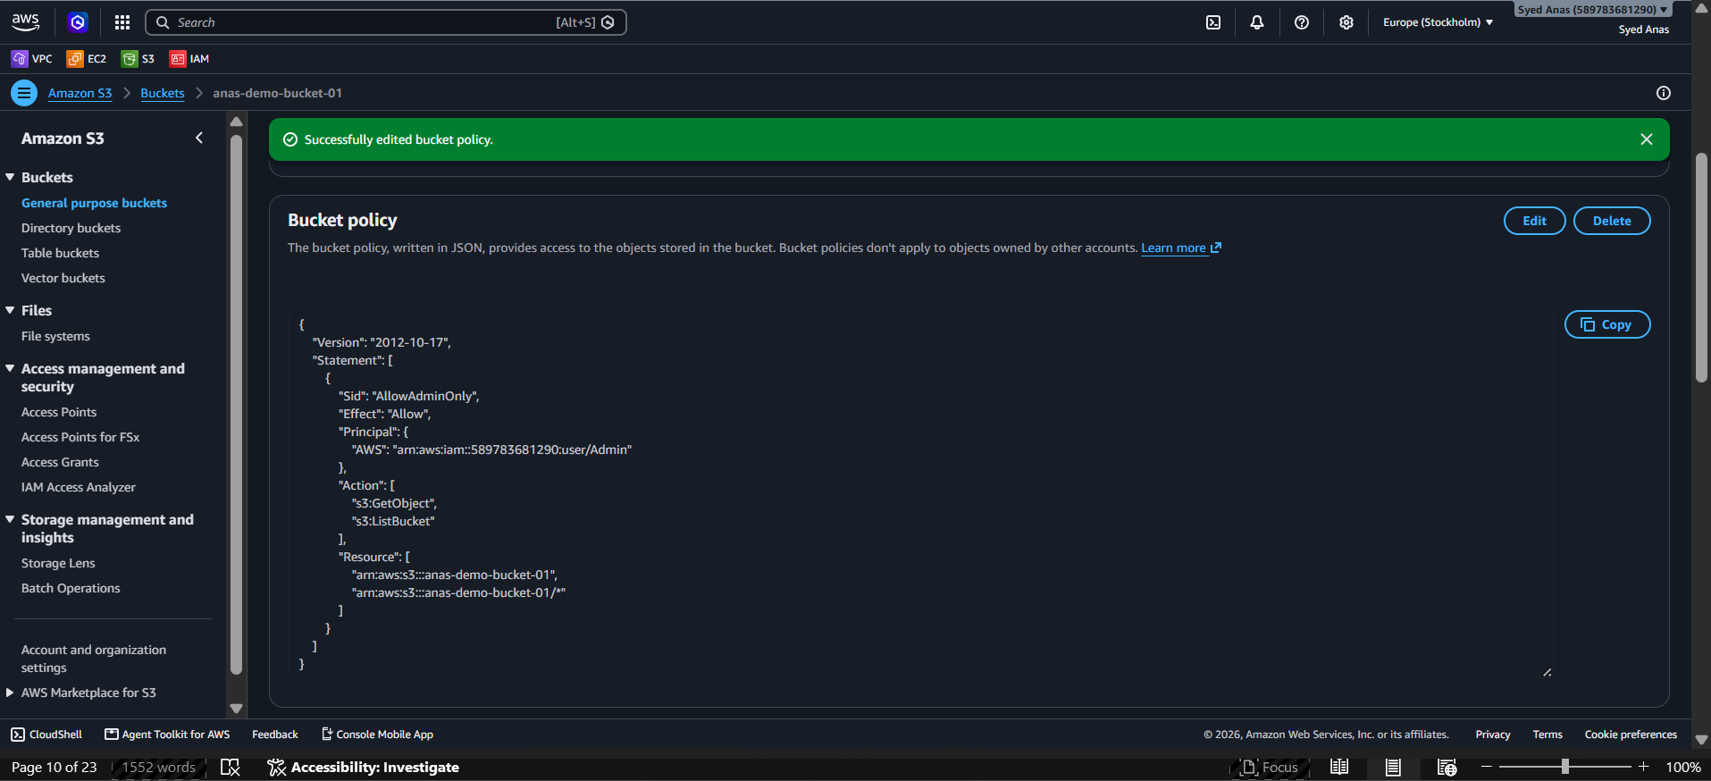
Step 4: Explanation of the Policy
Statement | Purpose
AllowOnlyAdminUserAccess | Grants the Admin user permission to list and read objects in the bucket.
DenyAllOtherAccess | Denies every other IAM user, role, or service from accessing the bucket or its objects.

Step 5: Test Access
- Login as Admin user → Try to view or download an object → ✅ Access should succeed.
- Login as another IAM user → Try to access → ❌ Access denied.
Optional: Add Write Permissions for Admin
If you also want the Admin to upload or delete objects, add:
"s3:PutObject",
"s3:DeleteObject"
under the "Action" array in the first statement.

- Set up lifecycle policies to automatically transition or delete objects based on specific criteria.
🧩 Scenario Example
You want to:
- Move objects to S3 Standard-IA (Infrequent Access) after 30 days.
- Move them to S3 Glacier Deep Archive after 90 days.
- Delete them permanently after 365 days.

🪣 Step 1: Open the S3 Bucket
- Go to AWS Management Console → S3 → Your Bucket → Management tab → Lifecycle rules → Create lifecycle rule.

⚙️ Step 2: Create Lifecycle Rule
Rule name: AutoTransitionAndDelete
Scope:
- Choose “Apply to all objects in the bucket”
(or you can target specific prefixes or tags, e.g., logs/, images/)

🕒 Step 3: Define Lifecycle Actions
✅ Transition Actions
- After 30 days, move to S3 Standard-IA
- After 90 days, move to S3 Glacier Deep Archive
✅ Expiration Actions
- Permanently delete objects after 365 days

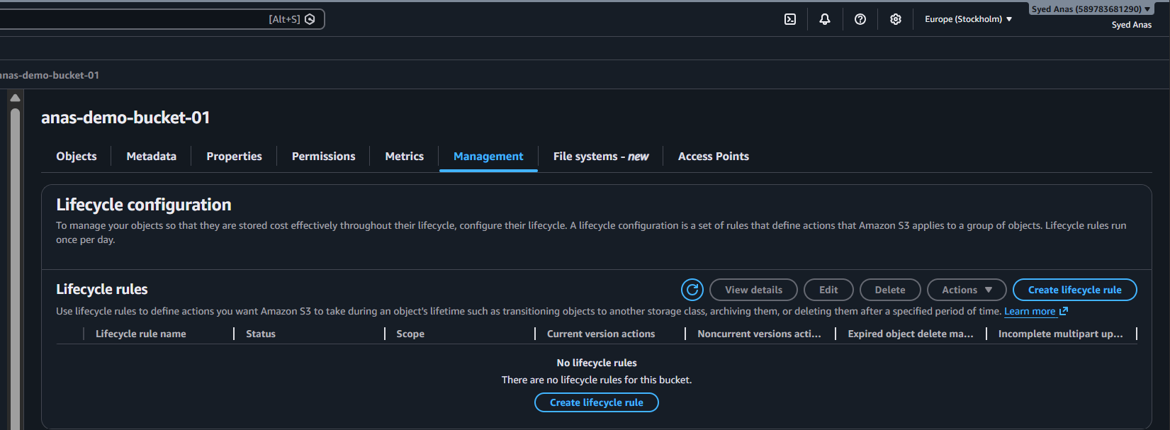

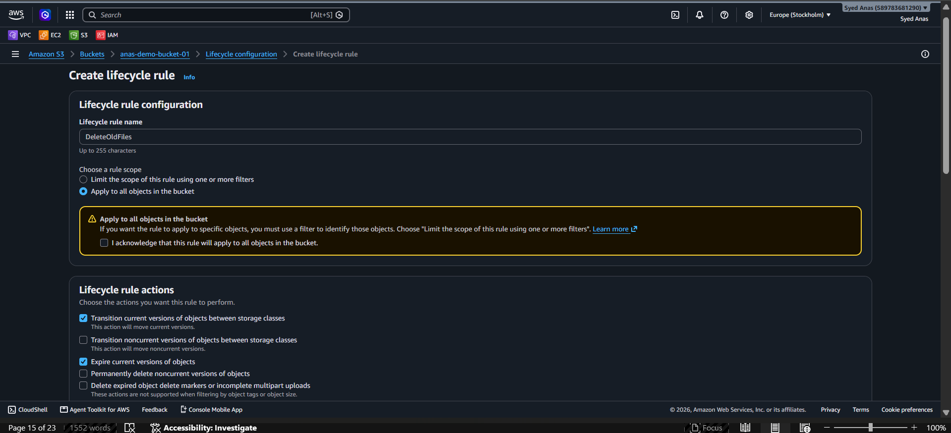

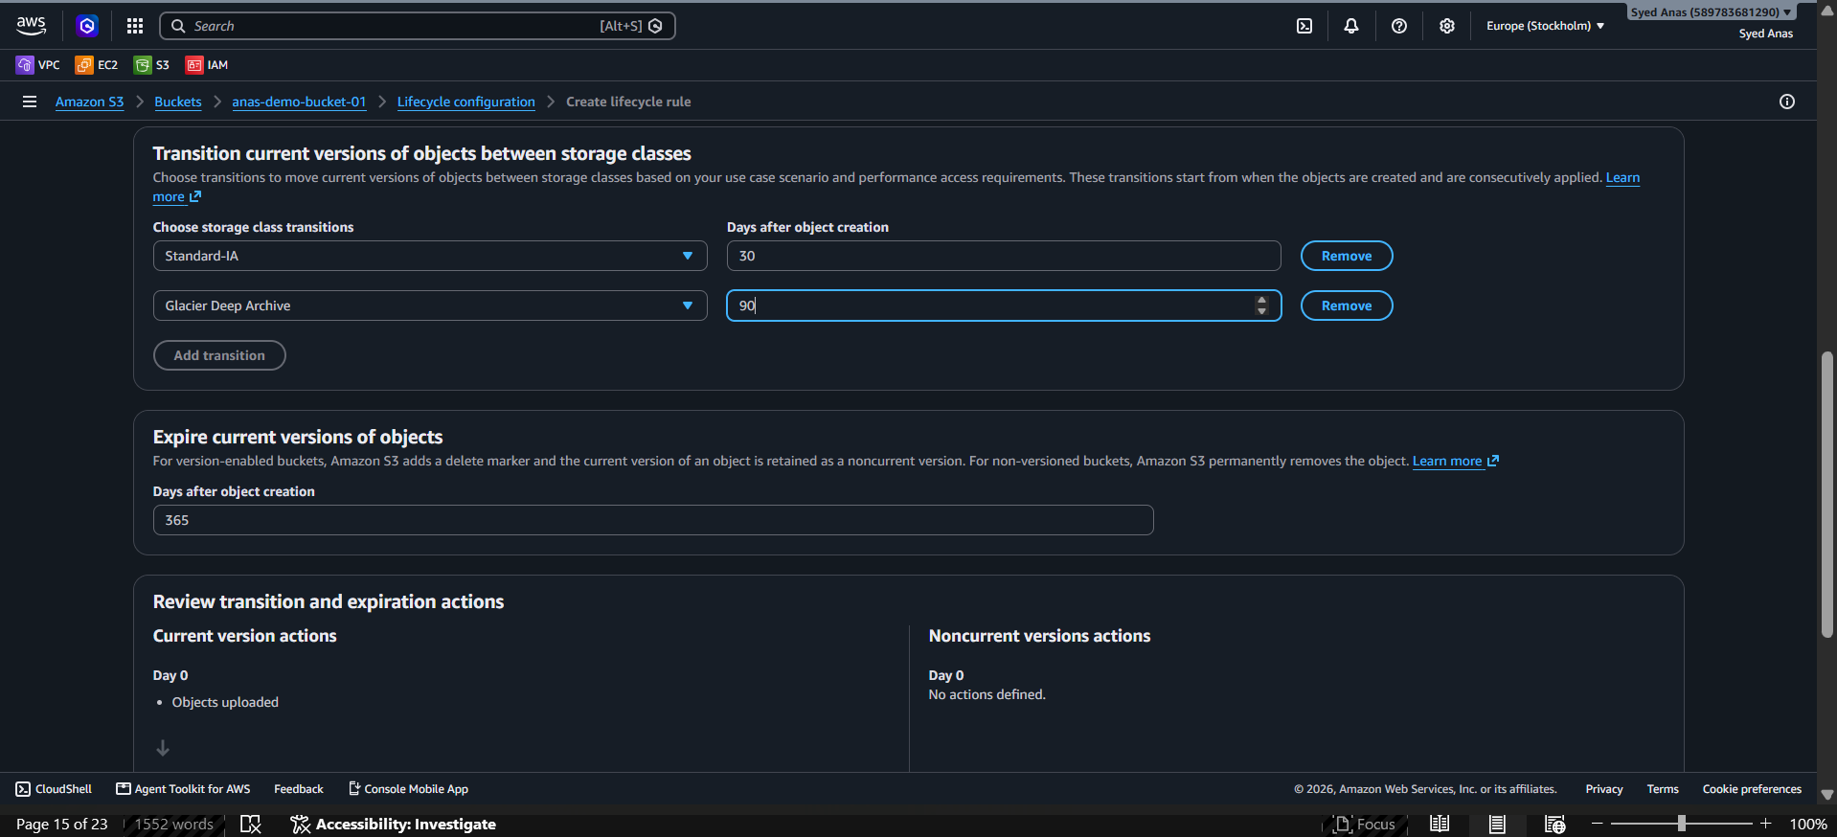

🧾 Example JSON Lifecycle Policy
If you want to create via CLI or Infrastructure-as-Code, use this JSON:
{
"Rules": [
{
"ID": "TransitionAndDeleteObjects",
"Status": "Enabled",
"Filter": {
"Prefix": ""
},
"Transitions": [
{
"Days": 30,
"StorageClass": "STANDARD_IA"
},
{
"Days": 90,
"StorageClass": "DEEP_ARCHIVE"
}
],
"Expiration": {
"Days": 365
}
}
]
}

💻 Step 4: Apply Lifecycle Policy via AWS CLI
Replace your bucket name below:
aws s3api put-bucket-lifecycle-configuration \
--bucket my-private-bucket \
--lifecycle-configuration file://lifecycle.json
(Where lifecycle.json is the JSON file you created above.)

Step 5: Verify Policy
Check your applied lifecycle configuration:
aws s3api get-bucket-lifecycle-configuration --bucket my-private-bucket
You should see the same JSON you uploaded.
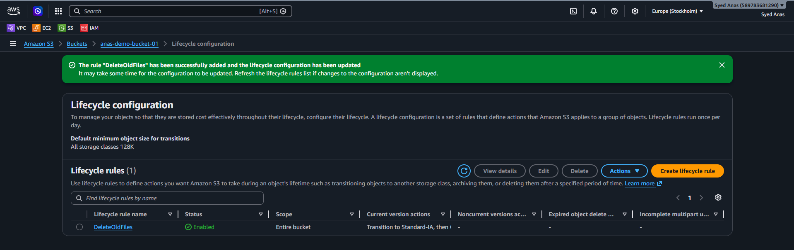
Key Points to Remember (Interview Tips)
Concept | Description
Transition | Moves objects to a cheaper storage class after a set time.
Expiration | Permanently deletes objects after a specified number of days.
Prefix or Tag Filter | You can apply lifecycle policies only to certain folders (e.g., logs/) or objects with specific tags (e.g., "Environment=Prod").
Glacier/Deep Archive | Used for long-term archival, not immediate retrieval. Retrieval can take hours.
Policy Status | Must be "Enabled" for it to take effect.

- Push some objects to S3 using the AWS CLI.

Step 1: Create an S3 Bucket
Example bucket name: my-demo-bucket-12345
aws s3 mb s3://my-demo-bucket-12345 --region ap-south-1
Output:
make_bucket: my-demo-bucket-12345
Step 2: Verify Bucket Created
aws s3 ls
Step 3: Create Some Files Locally
bash
mkdir ~/s3-demo
cd ~/s3-demo
echo "Hello from AWS CLI" > file1.txt
echo "Second file for upload" > file2.txt
Step 4: Upload Files to S3
bash
aws s3 cp file1.txt s3://my-demo-bucket-12345/
aws s3 cp file2.txt s3://my-demo-bucket-12345/
Step 5: Verify Upload
bash
aws s3 ls s3://my-demo-bucket-12345/
Output Example:

yaml

2025-10-13 15:00:00 21 file1.txt
2025-10-13 15:00:01 30 file2.txt
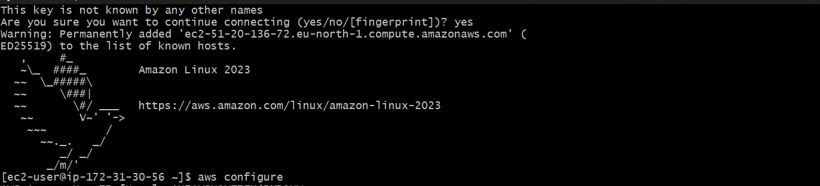
- aws --version – it shows the version
- Give aws configure
- Give AWS Access Key ID
- Give AWS Secret Access Key
- Region name (us-east-2)
- Output format (json
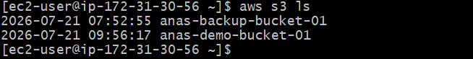

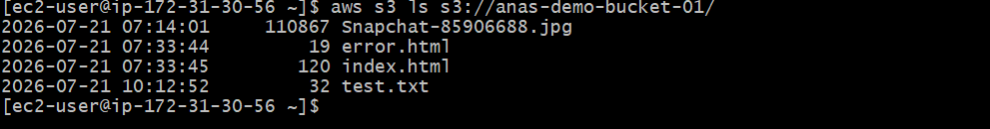

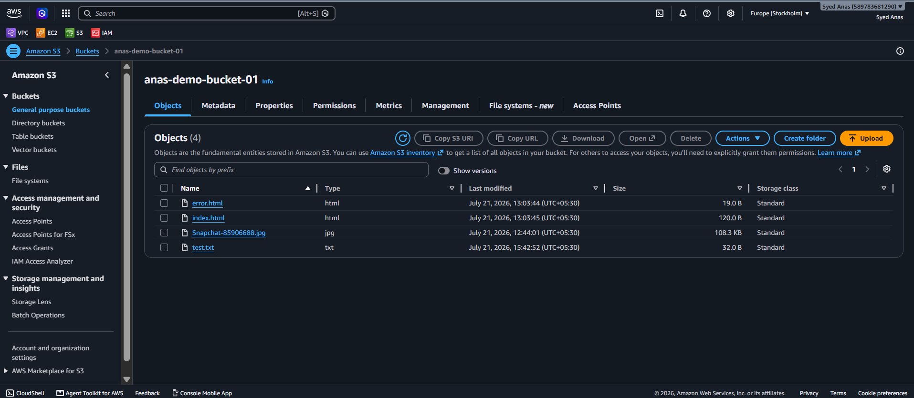

- Write a Bash script to create an S3 bucket.
Here’s a reusable script — you can automate bucket creation.

Step 1: Create Script File
vi create_s3_bucket.sh

Step 2: Paste Script

#!/bin/bash

# Script to create an S3 bucket

# Ask user for bucket name and region

read -p "Enter Bucket Name: " BUCKET_NAME

read -p "Enter AWS Region (e.g., ap-south-1): " REGION

# Create bucket

echo "Creating S3 bucket..."

aws s3 mb s3://$BUCKET_NAME --region $REGION

# Check if bucket created successfully

if [ $? -eq 0 ]; then

echo "Bucket '$BUCKET_NAME' created successfully in region '$REGION'."

else

echo "Failed to create bucket. Please check your permissions or bucket name."

fi

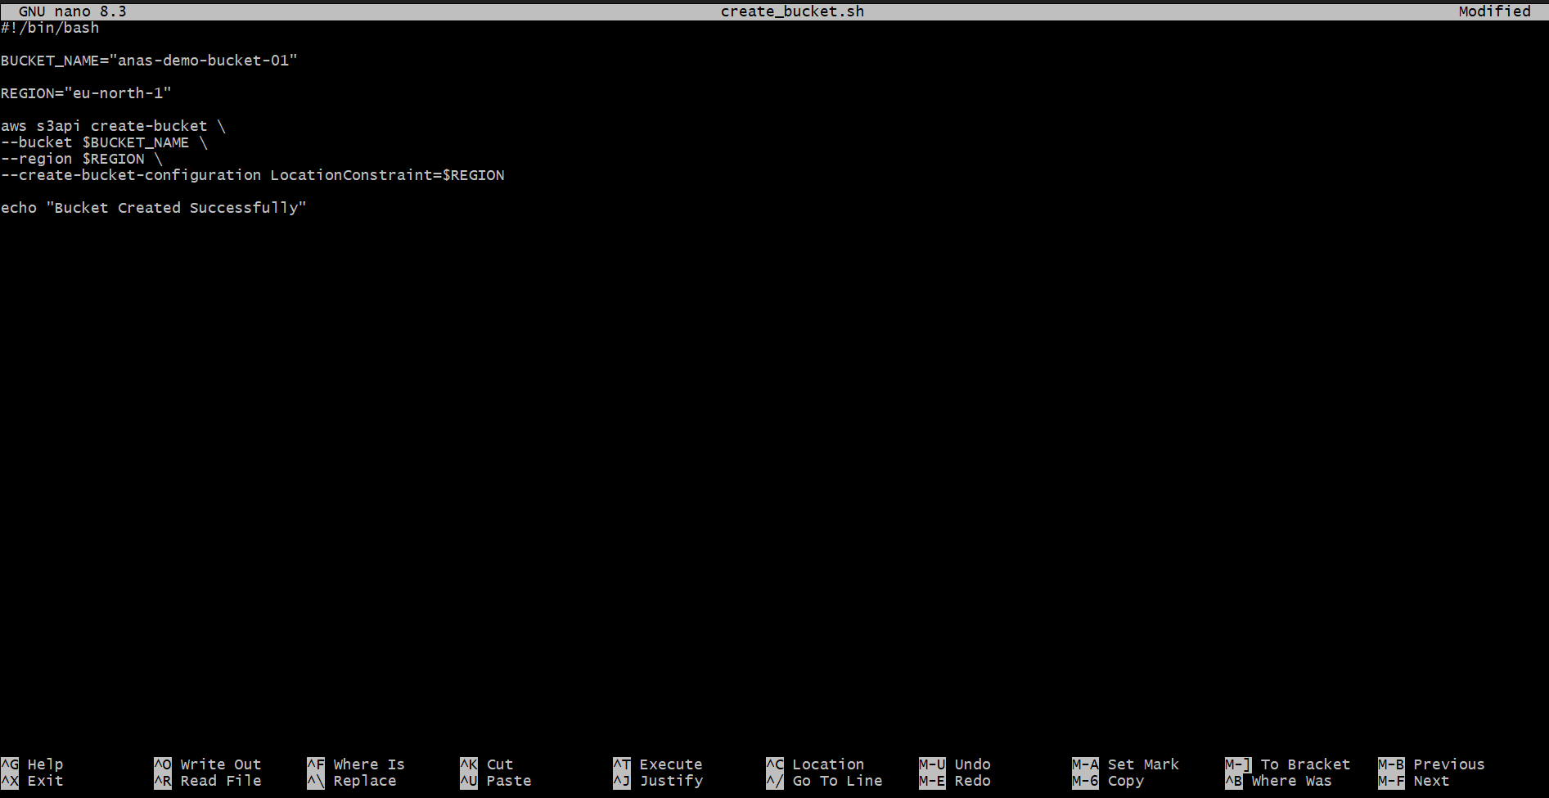

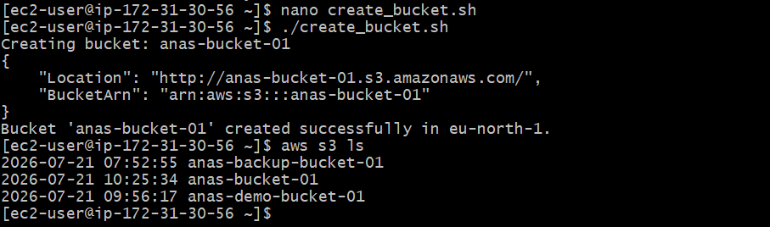

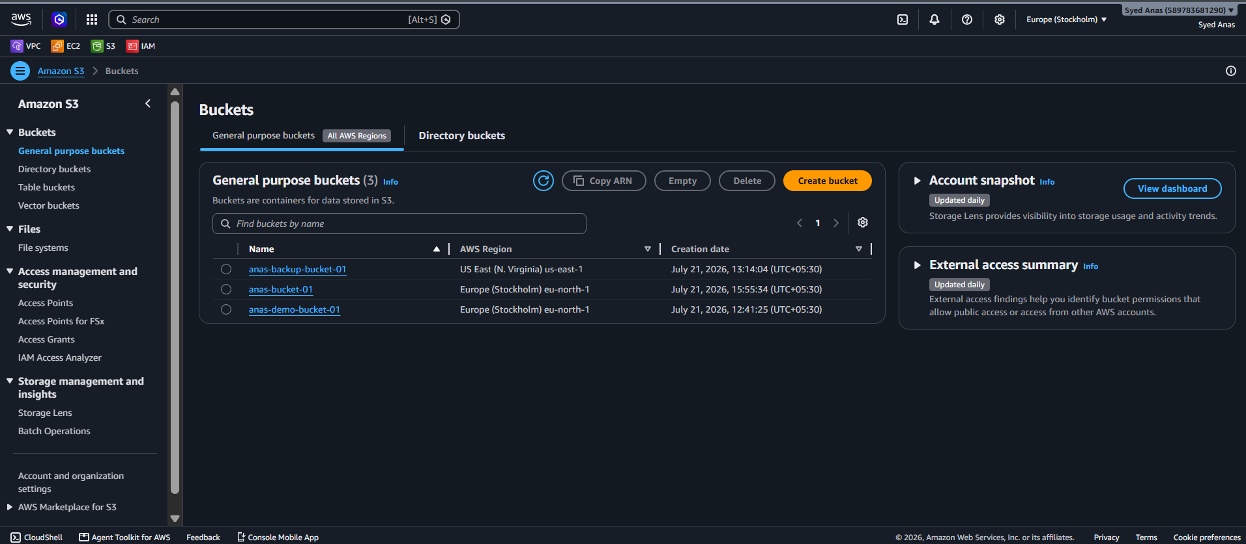

Step 3: Make Script Executable
chmod +x create_s3_bucket.sh

Step 4: Run Script
./create_s3_bucket.sh
✅ Example:
Enter Bucket Name: my-script-bucket-2025
Enter AWS Region (e.g., ap-south-1): ap-south-1
Creating S3 bucket...
make_bucket: my-script-bucket-2025
Bucket 'my-script-bucket-2025' created successfully in region 'ap-south-1'.

- Upload a 1 GB file to S3 using the CLI.

You can either use a dummy file generator or an actual large file.
- Step 1: Generate a 1 GB Dummy File
cd ~/s3-demo
fallocate -l 1G bigfile.img
- Verify:
ls -lh bigfile.img
Output:
-rw-r--r-- 1 user user 1.0G Oct 13 16:00 bigfile.img
- Step 2: Upload File to S3
aws s3 cp bigfile.img s3://my-demo-bucket-12345/
CLI will show progress:
upload: ./bigfile.img to s3://my-demo-bucket-12345/bigfile.img
- Step 3: Verify Upload
aws s3 ls s3://my-demo-bucket-12345/
You’ll see:
2025-10-13 16:05:00 1073741824 bigfile.img

- Optional Verification and Cleanup
Check all your buckets:
aws s3 ls
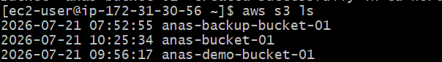
List contents of a specific bucket:
aws s3 ls s3://my-demo-bucket-12345/
Remove all files and delete bucket:
aws s3 rm s3://my-demo-bucket-12345 --recursive
aws s3 rb s3://my-demo-bucket-12345

